Homework 4 – Timers/Counters

Assigned Date: Friday, October 19, 2012

Due Date: Friday, October 26, 2012

Weight: 60 pts

Problem 1 (10 points total)

Let’s say that we take our peripheral clock (40 MHz) and divide it by 64. We call the divided frequency clock Tn_{Clk,} and use this clock to control the incrementing of our 16-bit timer/counter. Let’s further add that we toggle the signal produced by our timer/counter every time the 16-bit timer matches our period register value of 0x07FF. What is the resulting frequency of our signal obtained (show the result to the hundredths place)? Show all calculations!

(40 * 10 ^ 6)/64 = 625000 Hz
0x07FF = 2047 base 10
625000/2047 = 305.33 Hz

Problem 2 (10 points total)

Provided the following diagram and the fact PR_{y} and OCxR remain constant, what is the resulting frequency of the OCx signal (show the result to the hundredths place)? What is the duty cycle of OCx (show the result to the hundredths place)? NOTE: assume TMR_{y} is incrementing every 1 microsecond.

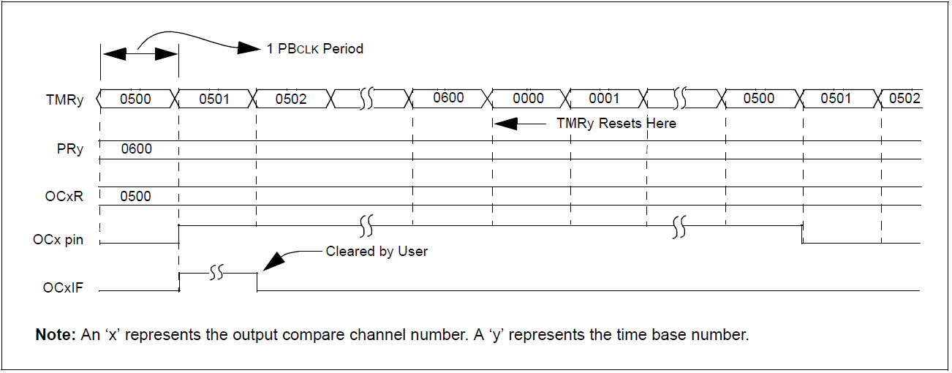

It toggles every time that the timer counts to 500. The period is at 600 but the 0Cx signal is on half the time in a 1200 micro second cycle. It take two period to complete what would be a proper cycle for the OCx pin.
1/1200 micro seconds = 833.33 Hz
Duty cycle = 600/1200 = 50%
Problem 3 (30 points total)

For each of the four periods shown below for the OCn signal, (a) calculate the period in seconds, (b) calculate the corresponding frequency, and (c) calculate the duty cycle as a percentage. Assume that TMRn is incremented at a frequency of clk_{Tn} = 80 MHz/8.

0x02AA
0x01FF
0x00FF
0x0FFF
0x000F

TMRn

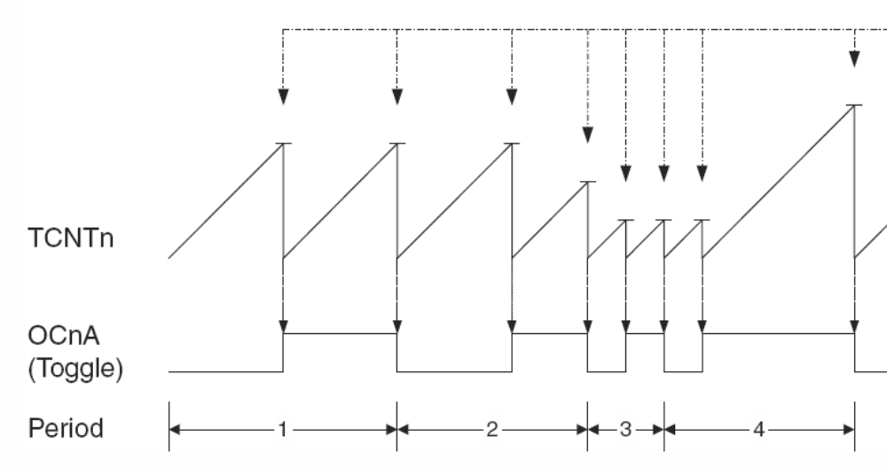

OCn
80MHz/8 = 10 MHz

Period 1: OFF/ON 0x02AA

- 0x02AA = 15*1 + 15*16 + 2*16*16 = 682
682 * 2 = 1364 <= counts per period
1364/10MHz = 1.36 * 10 ^ -4 s <= seconds in a period

b) 1/Period = 7331.38 Hz
c) Assuming its on for half from the diagram and a count is not given
then ½ *100 = 50%

Period 2: OFF 0x01FF ON 0x00FF

- 0x01FF + 0x00FF = 15 + 15 * 16 + 16*16 + 15 + 15*16 = 766 <= counts per period
766 / 10 MHz = 7.66 * 10^-5 s

b) 1/7.66 * 10 ^ -5 = 13054.83
c) 33.29 %

Period 3:

a) 3.00 * 10^-6 s
b) 333333.33 Hz
c) 50%

Period 4:

a) 4.11 * 10 ^-4
b) 2433.09 Hz
c) 99.64 %

Problem 4 (10 points total)

List and describe 5 real-world applications in which 16-bit and/or 32-bit timers may be used.

Power Relays – Measuring data and timing is especially important in relay protection. You might use a timer simply to keep track of time so you can communicate effectively and synchronize with other relays.

Electronic Door Locks – Counts for a set amount of time and if no one opens it then the door would reclose the lock.

Computer Monitors – They go into sleep mode after some time delay.

DC-Motor Control – You need to create a PWM signal that you can use to control your motors. This needs timers to determine the frequency of your pulses.

Digital Clock – Clock needs timers to know when to increment its display.

You need timers for any system that depends on relative time. Except for purely reactionary or analog devices you must have timers.

